Que 1) Plot a histogram,

10, 13, 18, 22, 27, 32, 38, 40, 45, 51, 56, 57, 88, 90, 92, 94, 99

|  |  |
| --- | --- |
| Frequency | interval |
| 1 | 0-10 |
| 2 | 10-20 |
| 2 | 20-30 |
| 2 | 30-40 |
| 2 | 40-50 |
| 3 | 50-60 |
| 0 | 60-70 |
| 0 | 70-80 |
| 2 | 80-90 |
| 3 | 90-100 |

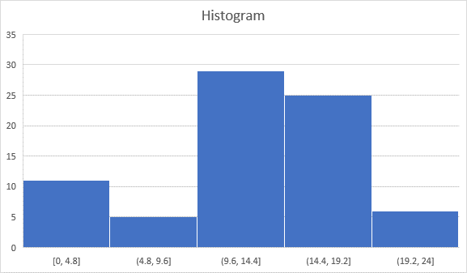

Que 2) In a quant test of the CAT Exam, the population standard deviation is known to be 100. A sample of 25 tests taken has a mean of 520. Construct an 80% CI about the mean.

Answer:

Confidence interval CI = x +/- z*(s/square root of n

Where x= mean

Z* = z star

S = Stanadard deviation

n=25

Therefore, CI = 520+/- 1.282( 100/5)

= 520+-1.282(20)

= 520+-25.64

80% Confidence interval = 494 to 546

Que 3) A car believes that the percentage of citizens in city ABC that owns a vehicle is 60% or less. A sales manager disagrees with this. He conducted a hypothesis testing surveying 250 residents & found that 170 residents responded yes to owning a vehicle.

1. State the null & alternate hypothesis.
2. At a 10% significance level, is there enough evidence to support the idea that vehicle owner in ABC city is 60% or less.

Que 4) What is the value of the 99 percentile?

2,2,3,4,5,5,5,6,7,8,8,8,8,8,9,9,10,11,11,12

Answer:

Value of 99 percentile = Percentile/100* (n+1)

= 99/100*(20+1)

= 0.99* (21)= 20.79 index value

Que 5) In left & right-skewed data, what is the relationship between mean, median & mode?

Draw the graph to represent the same.

